|  |  |
| --- | --- |
| How to | D:\projecten\1210326 MDBA ROWS (local, See N)\C. Report - advise\Workshops\2015-02 workshop 3 UAT, end user training\Screenshots\DELTARES_ENABLING_RGB.pngSource - Prepare Evaporation data for Source RO |
| Description | D:\Software_delft-fews (local, See P)\Marketing\Icons (FEWS_logo_icon)\Delf-FEWS-256x256.pngCreate short term forecast and combine with observed and outlook |
| Comments | Please be aware that the screenshots may deviate slightly from the application |
| version | 2016-01 |

Climate (Evaporation) are location based time series, created by merging 3 types of data:

* Observations (OPO)
* Long term forecast, based on a yearly pattern for 3 different regions (upper, middle and lower).
* Modifiers defined by the user, for example to represent a heatwave

To create the evaporation data:

1. Run the workflow to combine the available observations and long term forecast
2. Analyse recent temperature recordings for all locations in the *Plot overview* and the *Plots* display, to determine if a modifier is required for any of the 3 regions.
3. Modify (the short term forecast in) the resulting combined time series for each of the 3 regions as required (in the *Modifiers* display). The modifiers are multiplied with the EVAP time series.
   1. By default the modifier time series has a length of 2 weeks. This can be adjusted with the *start and end time*.
   2. The time series can be modified with different *Operations*:
      1. Time series: edit each time step separately
      2. DON’T USE THE OTHER OPTIONS (Add, Subtract, Multiply, Divide, Replace, Missing, Ignore)
   3. Modifiers can be applied per region, or for multiple regions simultaneously.
4. 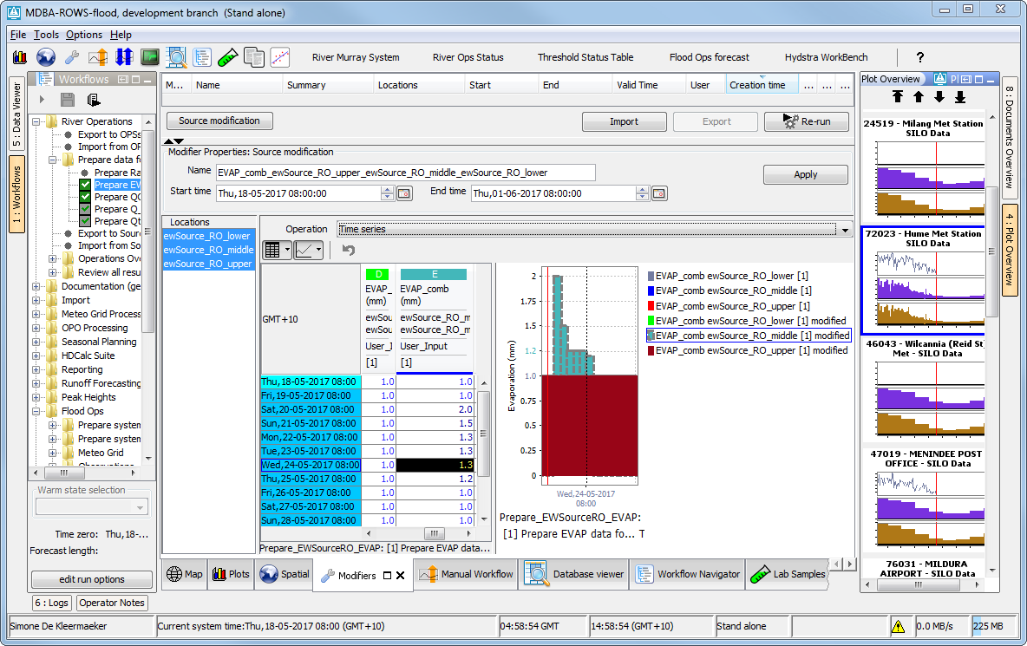*Apply* modifiers and *Re-run* the workflow

1

4

3a

3c

3b

2

3